COMHAIRLE CHONTAE LONGFOIRT

LONGFORD COUNTY COUNCIL

Corporate Affairs,
Aras an Chontae,
LONGFOIRT.

20th February 2014.

Chuig: Gach Ball don Chomhairle.

A Chomhairleoir,

The Monthly Meeting of Longford County Council which was due to take place on Wednesday, 19th February 2014 was adjourned as a mark of respect on the deaths of
Michael Killeen, retired County Manager, and John Donlon, former County Councillor.

The Adjourned February Meeting of the Council will take place on Thursday,
27th February 2014 at 3.00 p.m. in the Council Chamber, Aras an Chontae.

Mise le meas,
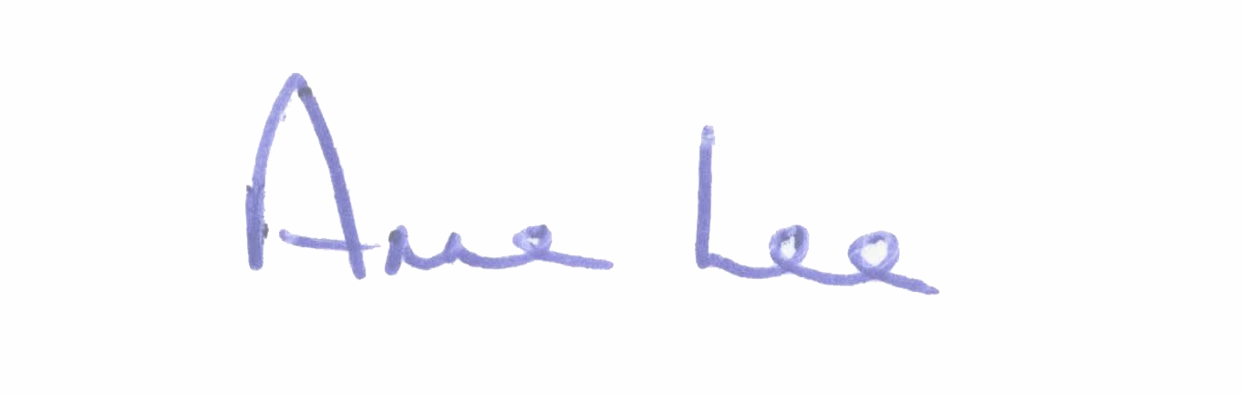

________________________
Anne Lee,
Meetings Administrator.

